Circuit exercises | Frequency
Bodyweight squat  This targets the thighs, hips, and gluteus. | 10-20 | 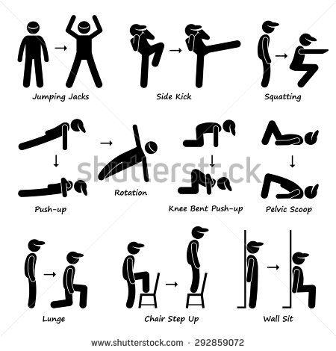
Tricep dip  This generally works the chest, triceps, and front shoulders. | 10-15 | 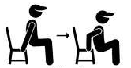
Walking lunges  This targets the gluteus,hamstrings and quadriceps in your thighs. | 10-20
Plank  This works your core. It also can help to elongate the spine, strengthen the arms and wrists, and increase balance. | 15-30 seconds | 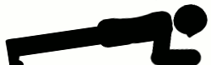
Jumping jacks  This targets you calf, thigh, core, chest and shoulder muscles. | 15-30 seconds
Side-lying leg lifts  This targets the hips and outer thighs. | 10-15 each side | 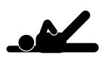
Pelvic floor lift  This targets the muscles around the bladder. | 10-15 times
This workout is designed to work all the major muscle groups.
Guidance notes
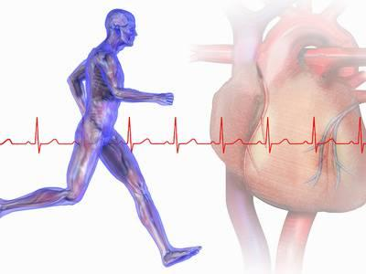
Warm up – Always do at least a 5 minutes warm up before any exercise routine.
Make sure you raise your heart rate and get your muscles warm to prevent injury. You can jog on the spot, skip, pedal on a stationary bike or jog up and down stairs.

Cool down – After any exercise you must perform some basic stretches to reduce your heart rate gradually and to stretch out and rebuild used muscles, for approximately 10 minutes.

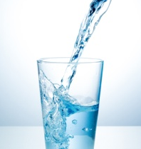

Remember to stay hydrated and drink eight glasses of water per day.

*If you are not used to regular exercise, have heart/lung disease symptoms, pregnant, recovering from an injury, obese etc.), please consult a physician before starting any exercise.

How often?
 | Exercise type | Beginners | Intermediate/Advance
Monday | Circuit exercises | 1 complete circuit | 2-3 complete circuits with 3-5 minute rest between each circuit
Tuesday | 1-2 k walk/run/yoga/pilates/swim/cycle
Wednesday | Circuit exercises | 1 complete circuit | 2-3 complete circuits with 3-5minute rest between each circuit
Thursday | 1-2 k walk/run/yoga/pilates/swim/cycle
Friday | Circuit exercises | 1 complete circuit | 2-3 complete circuits with 3-5 minute rest between each circuit
Saturday | 1-2 k walk/run/yoga/pilates/swim/cycle
Sunday | Rest

